🗒️ Notes: Python Day 27 (Matplotlib & Seaborn)
1. Setup: Importing Libraries
Before plotting, we import the necessary libraries. This is a standard setup for most data analysis and visualization tasks.
import numpy as np
import pandas as pd
import matplotlib.pyplot as plt
import seaborn as sns

import warnings
warnings.filterwarnings('ignore')
- numpy (as np): Used for numerical operations.
- pandas (as pd): Used for loading and managing data (like reading CSVs).
- matplotlib.pyplot (as plt): The primary library for creating plots.
- seaborn (as sns): A high-level library built on Matplotlib for more statistically-focused and visually appealing plots.
- warnings: Used to hide unnecessary warning messages to keep the output clean.

2. Matplotlib (plt)
Matplotlib is the foundational plotting library in Python. It provides a wide range of tools for creating static, animated, and interactive visualizations. We primarily use its pyplot module, aliased as plt.
2.1. Scatter Plots: plt.scatter()
A scatter plot is used to display values for two different variables, showing the relationship between them.
Data for Examples 1-6:
Python
x = [1, 2, 3, 4, 5, 6, 7, 8, 9, 10]
y = [2, 3, 5, 4, 3, 2, 5, 7, 8, 9]
Example 1: Basic Scatter Plot
This plot shows the basic syntax and introduces the label, marker, and s (size) parameters.
Python
plt.scatter(x, y, label="do somthing", marker="*", s=400)
plt.legend()
plt.show()
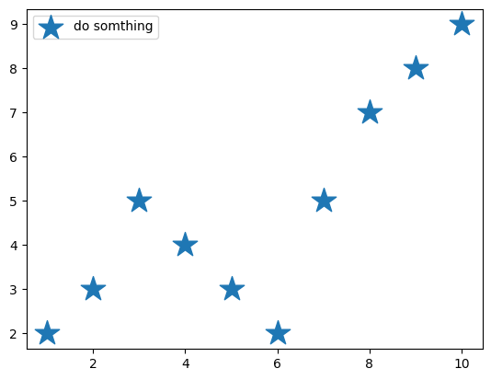
Example 2: Changing Color and Marker
This example shows how to set a specific color and a different marker style.
plt.scatter(x, y, label="do somthing", color="teal", marker="<", s=400)
plt.legend()
plt.show()
- color="teal": Sets the marker color to teal.
- marker="<": Uses a left-pointing triangle as the marker.
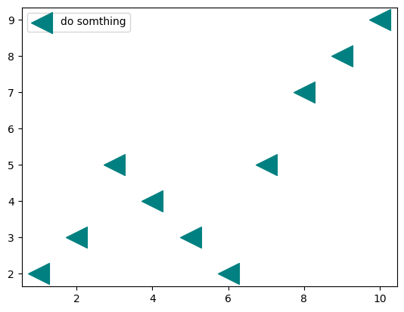
Example 3: Adding a Grid
This example uses a + marker and introduces plt.grid() to add a grid to the background for easier reading.
Python
plt.scatter(x, y, label="do somthing", color="red", marker="+", s=400)
plt.legend()
plt.grid()
plt.show()
- plt.grid(): Adds a visible grid to the plot's axes.
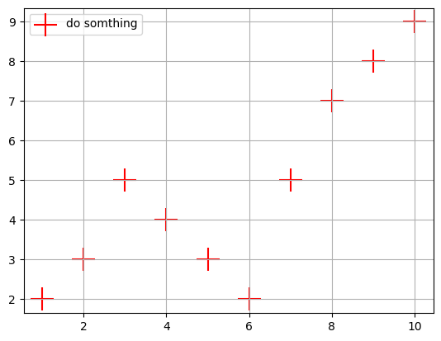
Examples 4-6: More Marker Customization
These examples demonstrate other available marker styles.
# Example 4: Upward triangle (^)
plt.scatter(x, y, label="do somthing", color="red", marker="^", s=400)
plt.legend()
plt.grid()
plt.show()
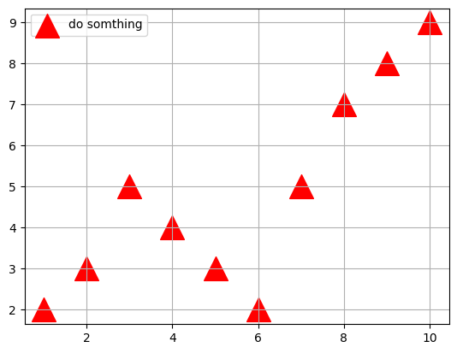
# Example 5: Square (s)
plt.scatter(x, y, label="do somthing", color="green", marker="s", s=400)
plt.legend()
plt.grid()
plt.show()
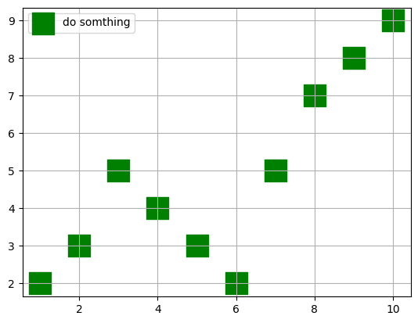
# Example 6: Tri-up (4)
plt.scatter(x, y, label="do somthing", color="red", marker="4", s=400)
plt.legend()
plt.grid()
plt.show()
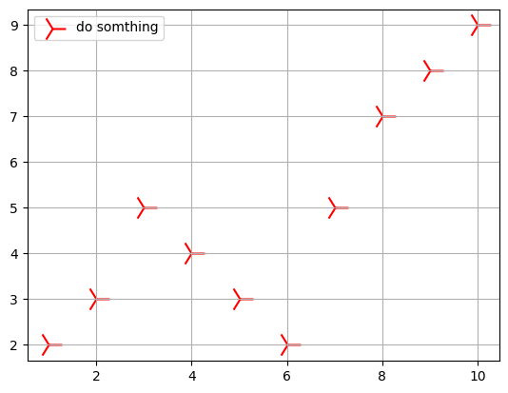
2.2. Pie Charts: plt.pie()
A pie chart is a circular chart used to show the proportion (or percentage) of different categories within a whole dataset.
Example 1: Basic Pie Chart
This example plots the distribution of products.
Python
count = [22, 34, 35, 10]
product = ["rings", "books", "pen", "bags"]
color = ["silver", "Brown", "blue", "green"]

plt.pie(count, labels=product, colors=color)
plt.legend(prop={"size": 8})
plt.show()
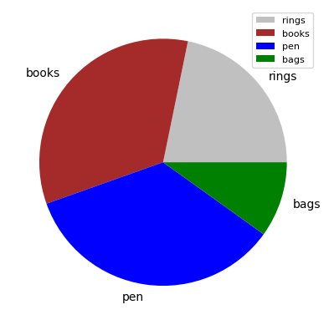

3. Seaborn (sns)
Seaborn is a powerful library built on top of Matplotlib. It's used for creating informative and attractive statistical graphics with very little code. It integrates well with Pandas DataFrames.
3.1. Loading Data for Seaborn
Seaborn works best with Pandas DataFrames. We first load a CSV file to use for the plots.
Python
# Load the dataset
a = pd.read_csv("Automobile_data.csv")

# Display the first 5 rows
a.head()

# Get information about the columns and data types
a.info()
3.2. Seaborn Plotting Examples
Example 1: Line Plot (sns.lineplot)
A line plot is often used to show a trend over a continuous interval or time. Here, it's used to plot a simple NumPy array.
Python
# Create sample data
x = np.arange(10)
y = np.sqrt(x)

# Create the line plot
sns.lineplot(y)
plt.grid(True)
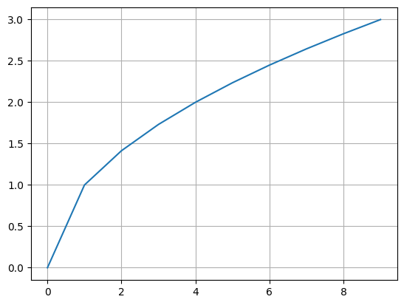
Example 2: Histogram (sns.histplot)
A histogram is used to show the distribution of a single numerical variable by grouping data into "bins."
Python
sns.histplot(a['price'])
- sns.histplot(a['price']): Automatically calculates bins and plots the frequency distribution for the 'price' column from the DataFrame a.
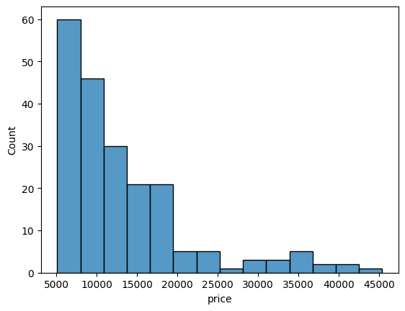
Example 3: Distribution Plot (sns.distplot)
A distplot combines a histogram with a KDE (Kernel Density Estimate) plot, which is a smoothed line showing the data's distribution.
Python
# Calculate mean and median for annotation
mwidth = a['width'].mean()
dwidth = a['width'].median()
# Create the distribution plot
sns.distplot(a['width'])
# Add vertical lines for mean and median
plt.axvline(mwidth, color='red')
plt.axvline(dwidth, color='yellow')
plt.grid(True)

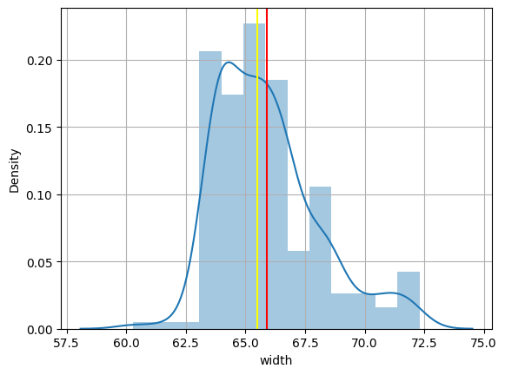
Example 4: Count Plot (sns.countplot)
A count plot is like a histogram for categorical data. It shows the count of items in each category.
# Example 4a: Vertical Count Plot
sns.countplot(data=a, x="body-style")
plt.grid(True)
- data=a: Specifies the DataFrame to use.
- x="body-style": Tells Seaborn to count the occurrences of each unique value in the 'body-style' column and plot them on the x-axis.
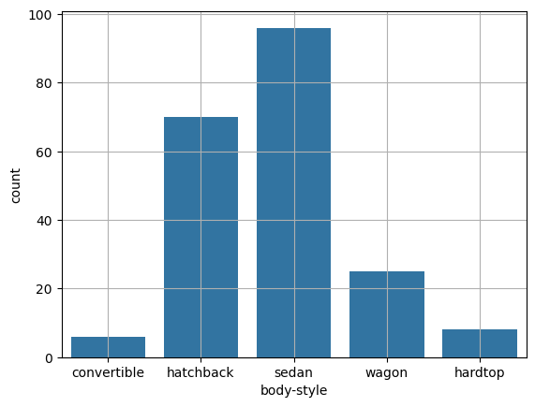
# Example 4b: Custom color and legend (Note: plt.legend() is used incorrectly here)
sns.countplot(data=a, x="body-style", color='Green')
plt.legend("Cars") # This line will not create a proper legend
plt.grid(True)
- Note: The command plt.legend("Cars") is not the standard way to create a legend. Seaborn legends are typically generated automatically by using the hue parameter (e.g., hue="fuel-type").
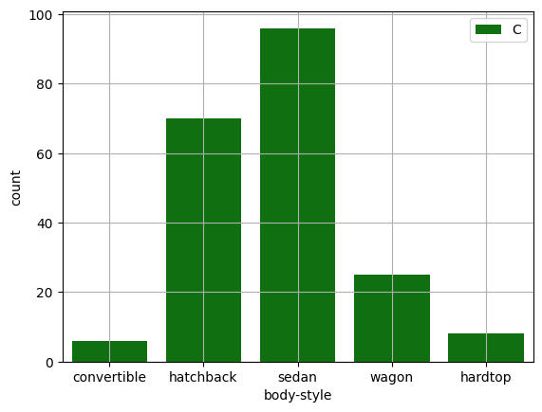
# Example 4c: Horizontal Count Plot
sns.countplot(data=a, y="make", color="m")
- y="make": By using y instead of x, the plot is drawn horizontally, which is useful when you have many categories or long labels (like car "make").
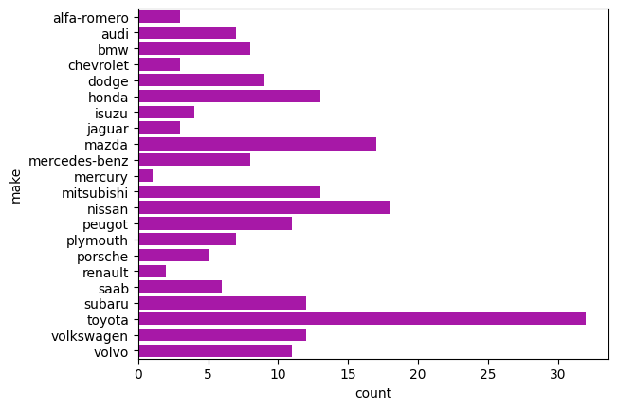
# Example 4d: Vertical Count Plot (different color)
sns.countplot(data=a, x="make", color="y")
- This plot shows the count by "make" on the x-axis. Because the labels overlap, the horizontal version (4c) is much more readable.

